

Midterm Project Report

Advanced Computer Programming

Student Name : Temuulen Baasankhuu
Student ID : 114021138
Teacher : DINH-TRUNG VU

2026-4-16

Introduction

Github
- Personal Github Account: https://github.com/FelizJueves56

- Group Project Repository: https://github.com/khulegu1025-ui/ACP-Group3/tree/main/Midterm

Overview
In this project, I used Python and the Scrapy framework to extract information from my GitHub profile page. The program collects data from all repositories listed under my account and saves the results into an XML file.
The extracted information includes:
- Repository URL
- About (description)
- Last Updated date
- Programming Languages used
- Number of Commits
Scrapy’s CSS selectors and XPath were used to locate elements inside GitHub’s HTML structure. The spider also follows links from the main repository list to individual repository pages to extract deeper information.

Implementation

Class 1 GithubSpider
This is the main spider class used for crawling GitHub repositories. It inherits from scrapy.Spider.

Fields
-“github” identifier used to run the spider.
-“start_requests()” Defines the starting URL (GitHub repository page).

Methods
- start_requests(self)
Sends the initial request to the GitHub repository page.

- parse(self, response)
Extracts all repository links from the profile page and sends requests to each repository page.

- parse_repo(self, response)
Extracts detailed information from each repository page:
    - URL
    - About
    - Last Updated
    - Languages
    - Number of Commits

Functions
- response.css : used to get data using CSS selectors

- response.xpath : used to find commit numbers

- .get : used to get single value

- .getall : used to get multiple values

- Strip : used to remove extra spaces

- response.urljoin : used to convert relative links into full URL

- If the repository has no description, the repository name is used as “About”.

- If languages or commits are missing, they are set to None.

- If both commits and languages are missing, all optional fields are set to None.

Results

Result 1 Successful Extraction
In this image the program successfully extracted repository information from my GitHub account.
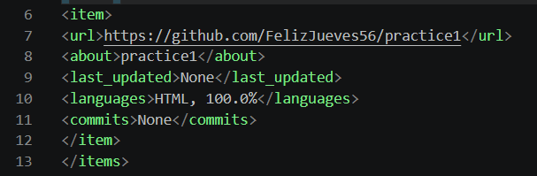

Conclusions
In this project, I learned how to use Scrapy to collect data from websites like GitHub. The spider is able to go through different pages and extract useful information automatically.
The final result is stored in XML format, which makes it easy to read and use later.
Overall, this project helped me understand web scraping, selectors, and how data extraction works in real websites.

